REQUÊTES SQL

INSERTION
> INSERT INTO Demande (Demande_id, Demande_type, Demande_description, Demande_date, Lieu_id, User_id) values
('DEM-022', 'Modification', 'Fontaine hors-zone à raccorder au réseau principal.', '2026-06-28 08:40:00', 'LIEU-004', 'CIT-002');

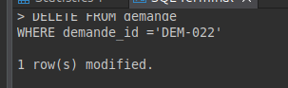
SUPPRESSION
> DELETE FROM demande
WHERE demande_id ='DEM-022';

MISE A JOUR
> UPDATE citoyen
SET user_name = 'Sofia Benali'
WHERE user_id = 'CIT-004';

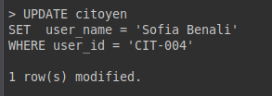

SELECTION
> SELECT *
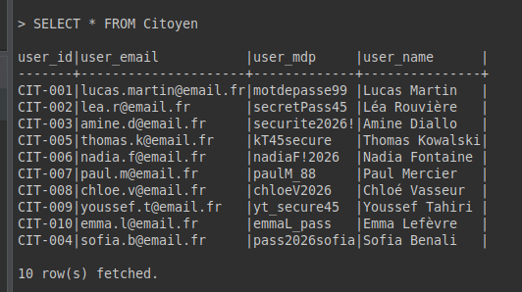
FROM Citoyen;

JOINTURE
> SELECT
D.Demande_id,
D.Demande_type,
D.Demande_description,
D.Demande_date,
C.User_name AS Citoyen,
C.User_email,
L.Lieu_id
FROM Demande D
JOIN Citoyen C ON D.User_id = C.User_id
JOIN Lieu L ON D.Lieu_id = L.Lieu_id
ORDER BY D.Demande_date DESC;

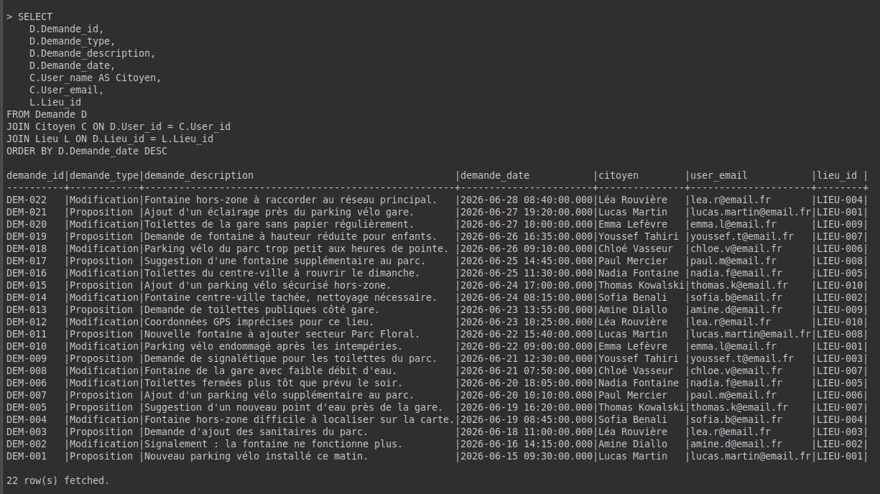

AGREGATION
> SELECT COUNT(demande_type)
FROM demande
GROUP BY demande_type ;

